**Topic: To supply leftover food to the poor**



**Title: FOOD CONNECT**

**Name:** Ishani Roy

**College Name:**

Academy of Technology, Hooghly, Adisaptagram

**University Roll no :** 16931121020

**Email Id:** ishani.roy.21@aot.edu.in

**Skillwallet ID :** SWUID20240050599

# Project Overview

# Food Connect is a Salesforce-based initiative designed to address food insecurity by connecting NGOs with surplus food resources. The primary aim is to ensure timely delivery of leftover and surplus food to underprivileged communities, thereby reducing food wastage and supporting sustainable food distribution. Utilizing Salesforce’s powerful CRM and automation capabilities, Food Connect creates a transparent and efficient platform for managing food donations, volunteer coordination, and beneficiary tracking.

# Objectives

List the specific, measurable goals the project intends to achieve. Examples:

**Business Goals** Establish a scalable, sustainable model for redistributing surplus food to communities in need.

**Specific Outcomes**:

• Optimize the logistics of food donation management to reduce food wastage.

• Enable real-time tracking and reporting of food distribution activities.

• Improve coordination among NGOs, donors, and volunteers.

# Salesforce Key Features and Concepts Utilized

* **Salesforce CRM:** Centralized data repository for NGOs, donors, and beneficiaries.
* **Automation (Flow & Process Builder):** Streamlined workflows for donation requests and volunteer task assignments.
* **Salesforce Maps & Geolocation Services:** Efficient routing and planning for food deliveries.
* **Reports & Dashboards:** Real-time insights into donation quantities, volunteer engagement, and impact metrics.

# Detailed Steps to Solution Design

The solution design included creating custom objects for donations, volunteers, and beneficiaries. Each object was mapped to relevant data points, ensuring data accuracy and ease of access. Screenshots and wireframes of the data model and interface were

# developed, emphasizing user-friendliness and data transparency. Business logic was implemented using Apex and Flow to ensure smooth processing of donation requests and task assignments. Step1: First ,we need to Create a developer org in salesforce and activate our Account.

# Step2: We need to create objects like Venue, Drop-Off point ,Task ,Volunteer ,Execution detail using test data type.

**Step3:** Creating the Tabs for the Objects, like Venue, Drop-Off Point, Task, Volunteer, Execution Details using suitable tab styles and Making sure that the append tab users’ existing personal customisations is checked.

**Step4:** To create a lightning app page Go to setup page >> search “app manager” in quick find ,select “app manager” then click on New lightning App. Fill the App Name : **Food Connect**. To Add Navigation Items Search for the item in the (Home, Venue, Drop-Off Point, Task, Volunteer, Execution Details, Reports) from the search bar and move it using the arrow button.

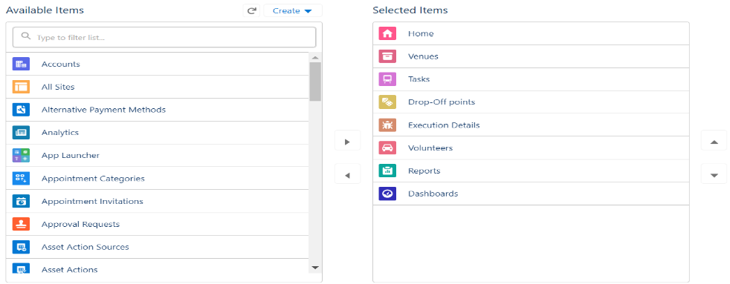

To add user profile add the system administrator as well, in my case it was “Ishani Roy”.

**Step 5:** Creation of Relationship fields in objects like:Creation of Lookup Relationship Field on Volunteer Object, Creation of Master Detail Relationship Field on Execution Details Object, Creation of Master Detail Relationship Field on Execution Details Object, Creation of Lookup Relationship Field on Drop-Off Point Object, Creation of Lookup Relationship Field on Task Object, Creation of Lookup Relationship Field on Task Object, Creation of fields for the Venue object, Creation of fields for the Drop-Off point object,Creation of fields for the Task object like task Id , date etc, Creation of fields for the Volunteer object like volunteer id , gender, age etc.Creation of field for the Execution Details object like execution id.

**Step 6:** Creating screen Flow naming it as ‘Venue Form’ to create a record in Venue object , adding components like Venue Details ,Venue Name ,Email ,Phone, Venue Location , Latitude ,longitude, Create Venue Record**.**

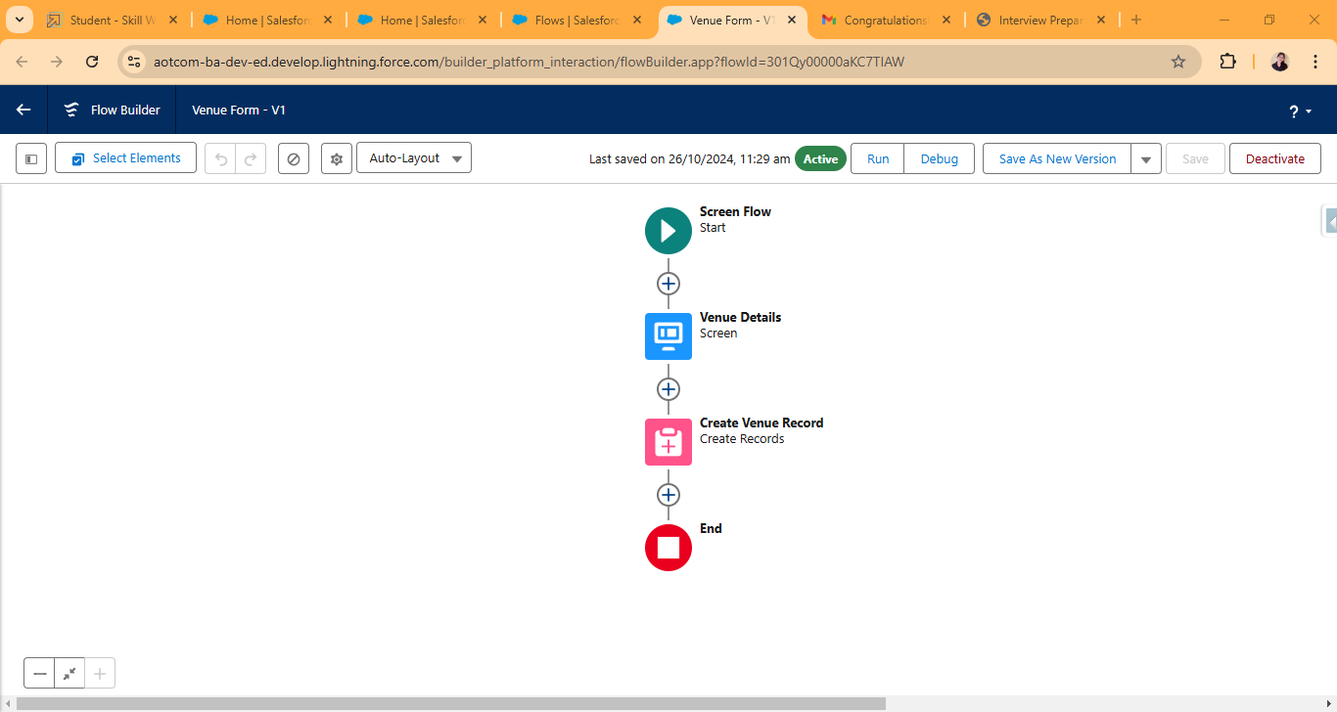

**Step 7:** Log into the trailhead account, navigate to the gear icon in the top right corner.Click on developer console and you will be navigated to a new console window. Create a TRIGGER enter name : DropOffTrigger , sObject: Drop-Off Point. Write this Trigger code:

**Code:**

trigger DropOffTrigger on Drop_Off_point__c (before insert) {

    for(Drop_Off_point__c Drop : Trigger.new){

        Drop.Distance__c = Drop.distance_calculation__c;

    }

}

**Step 8:** Clone a Standard Platform User Profile from ‘Profiles’ and name it ‘NGOs Profile’.

**Step 9:**Now creating 3 users, Iksha Foundation, Manavseva Foundation , Seva ashram, along with their First Name ,Last Name, Alias ,Email, Username ,Nickname ,User License ,Profile ,Active status. 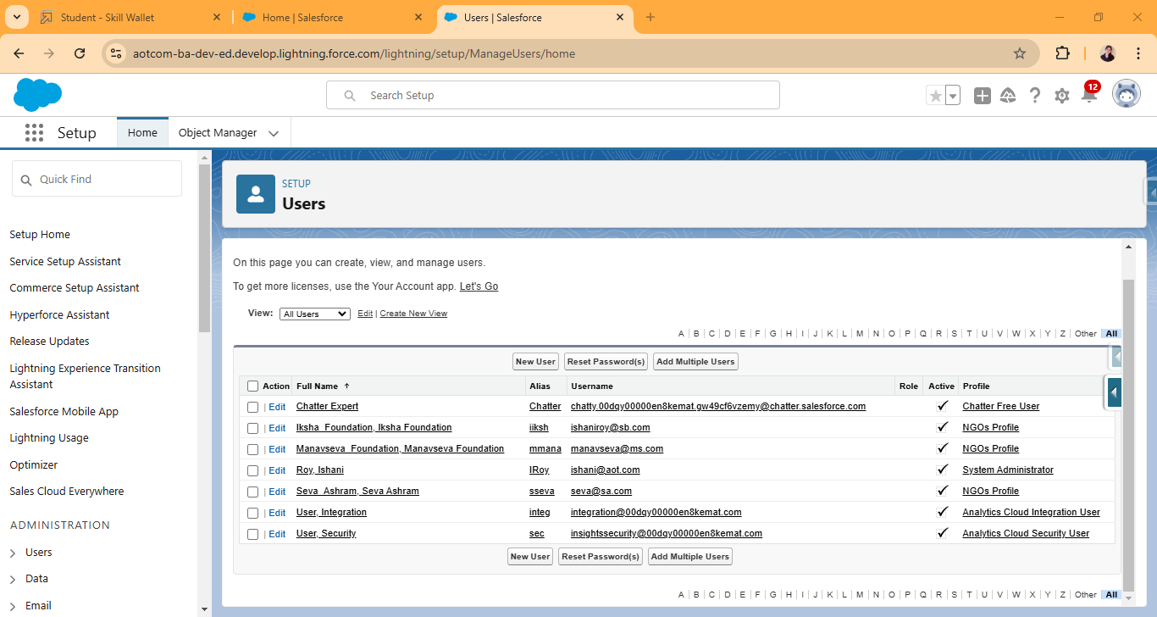

**Step 10:** Create 3 public groups for Iksha foundation, Manavseva Foundation , Seva Ashram. In Selected Members and Add System Administrator, here Ishani Roy.

**Step 11:** Create Custom Report Type:

Primary Object : Select Venues ,Report Type Label : Venue with DropOff with Volunteer,Report Type Name : Venue_with_DropOff_with_Volunteer , Description : Venue with DropOff with Volunteer, Store in Category : Select Other Reports, Deployment Status : Deployed, Near Click to relate another Object Select Drop-Off Points, also select "A" records may or may not have related "B" records, Now again Near Click to relate another Object Select Volunteers, Save.

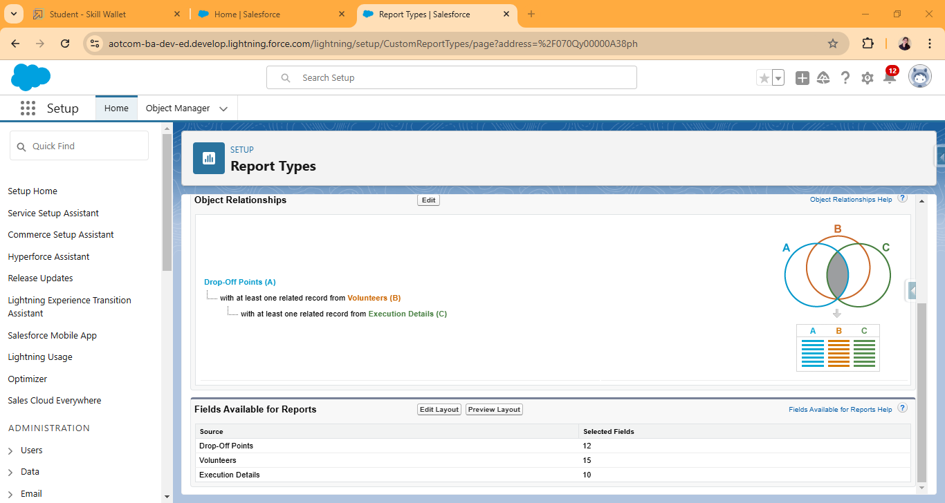

**Step 12:** Creation of Report on Venue with DropOff with Volunteer. Report Name : venue and Drop Off point , Select Report Type : Venue with DropOff with Volunteer, In GROUP ROWS : Add Volunteer Name, In Columns : Add Venue Name, Drop-Off point Name, Distance.

Creation of Report on Volunteers with Execution Details and Tasks, Report Name : Volunteer Task , Select Report Type : Volunteers with Execution Details and Tasks , In GROUP ROWS : Volunteer ID , In Columns : Add Volunteer : Volunteer Name, Task : Task Name, Execution Detail : Execution Detail Name, Volunteer: Owner Name, Task: Date, Task : Rating.

**Step 13:** Adding venue and Drop Off point Report to the dashboard, Volunteer Task Report to the Dashboard , a Picture to the Dashboard . Folder Label : Custom Dashboards, Name : Organization Details ,on Widget and select Chart or Table , Select Report : Select venue and Drop Off point Report. In Add Component select Display As : Select Lightning Table ,Component Theme : Select Dark (Optional), save. For adding **Volunteer Task Report to the Dashboard** in Add Component select Display As : Select Line Chart, Component Theme : Select Dark (Optional).

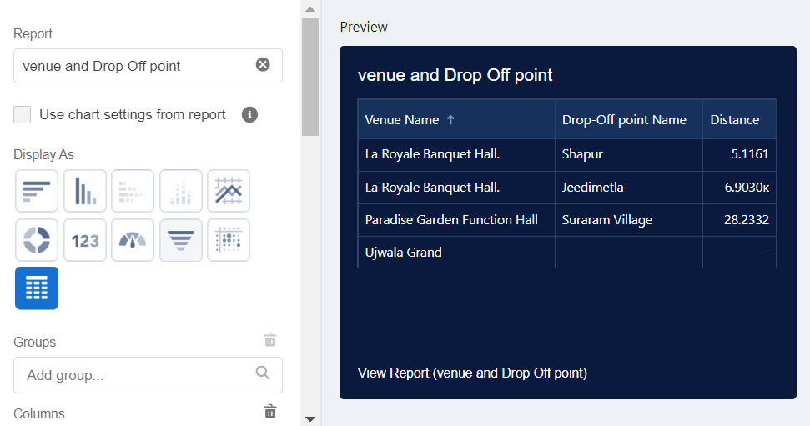

**Step 14:** Creating sharing rules for dropoff point ,labelling them as RULE1,2 and 3 , assigning fields and operators.

**Step 15:** At last setting up the home page. Click on the Lightning App Builder and Select the New. Select Home Page and give Label as HOME Page. Select Standard Home Page. Near Components search for Flow and Drag and Drop in Right Side Section.. On the right hand side:

Flow : Venue Flow ,Near Components search for Dashboard, then Drag and Drop it in first Section.

Click on Save and Activation, then click on App Default, then Add Assignments.

Add FoodConnect App and then Save.

FoodConnect Home Page would Look Like this.

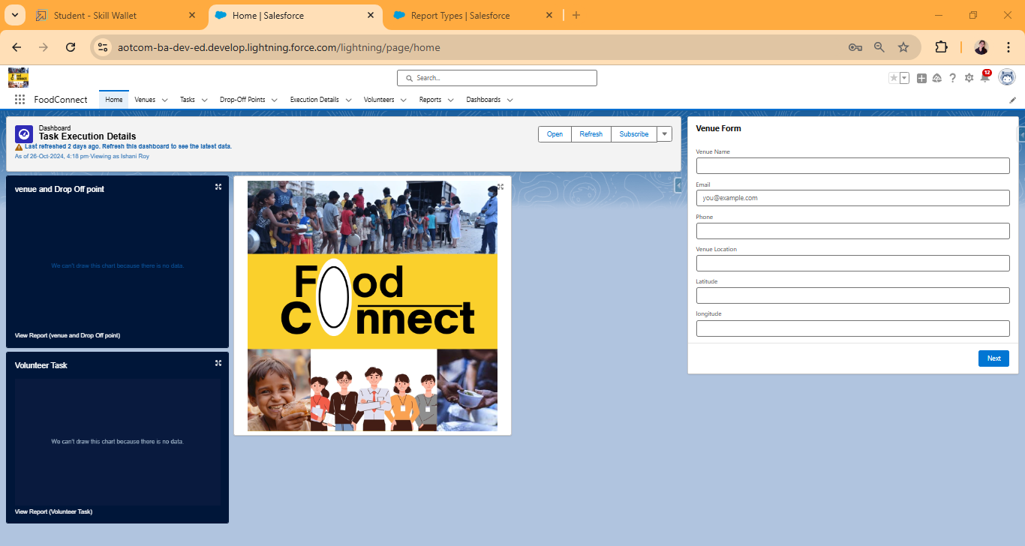

# Testing and Validation

• **Unit Testing:** Apex classes and triggers were rigorously tested to ensure the robustness of the donation request and volunteer assignment processes.

• **User Interface Testing:** Verified user experience, checking for responsiveness, data accuracy, and ease of use across devices.

# Key Scenarios Addressed by Salesforce in the Implementation Project



* **Donation and Resource Allocation:** Automated processes to match food donations with beneficiaries based on need and availability.
* **Volunteer Task Assignment:** Dynamic allocation of tasks to volunteers based on location, availability, and priority.

# ****Impact Reporting:**** Real-time data visualization through dashboards to showcase project impact.

# 7.Conclusion

By leveraging the Salesforce platform, Food Connect has established an organized, transparent system for managing surplus food donations, enhancing coordination among NGOs and ensuring timely delivery to those in need. The project successfully addressed food insecurity while maximizing the efficient utilization of available resources.